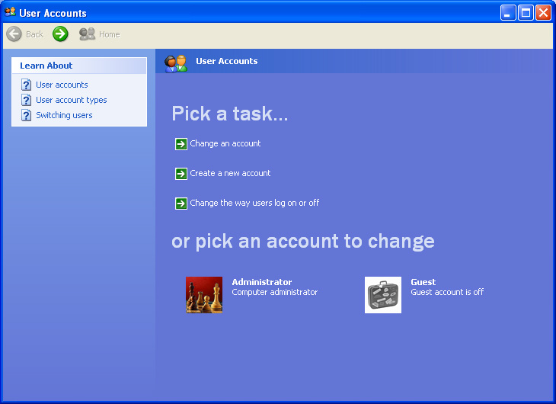
Hidden Administrator Account in Windows XP

In Windows XP Home there is an Administrator Account that is not visible during regular usage and that is not protected with a password. Following steps have to be fullfilled to set a password:

- Restart your computer

- While the computer starts press »F8« to get to the Windows Startmenu. There you can choose between several starting options.

- Choose the save mode

- Choose the Administrator Account (no password required)

- Press »Start«
- Click on »Control Panel«
- Make sure, that you see the classic view (top left)
- Make a doubleclick on »User Accounts«

- Click on »Change an account«
- Choose the Administrator Account
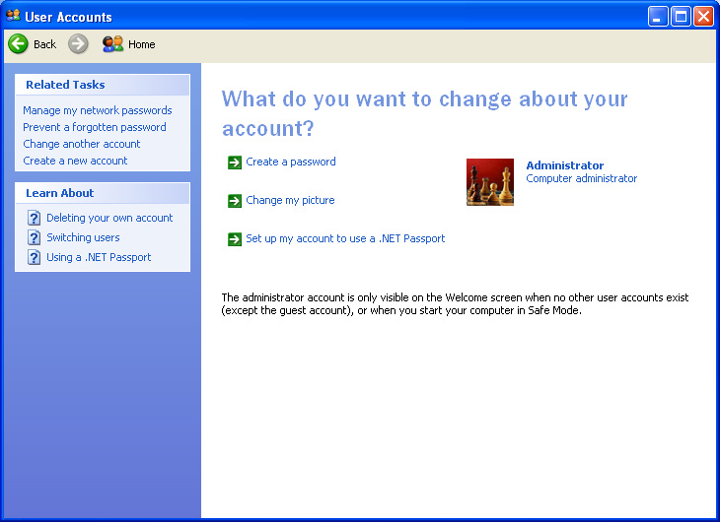
- Click on »Create a password«
(The Password should not be Administrator or easy to guess)

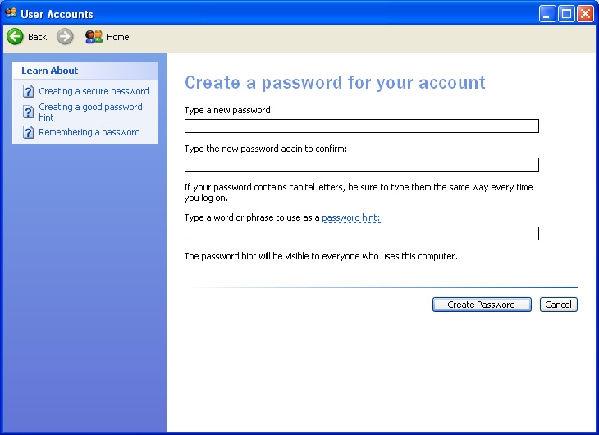

- Restart your computer

